LAB 1 - Git and GitHub Lab

Louis Philip Buenaflor

Professor, Katherine Argall

January 24, 2024

My GitHub repo Lab1 url: <https://github.com/philippoops/PhilipB.git>

1. Configure Git  
   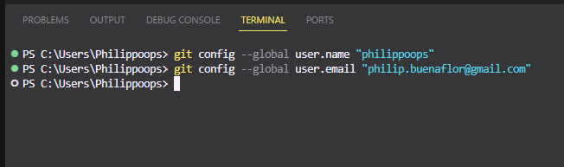
2. Create git Repository on GitHub  
   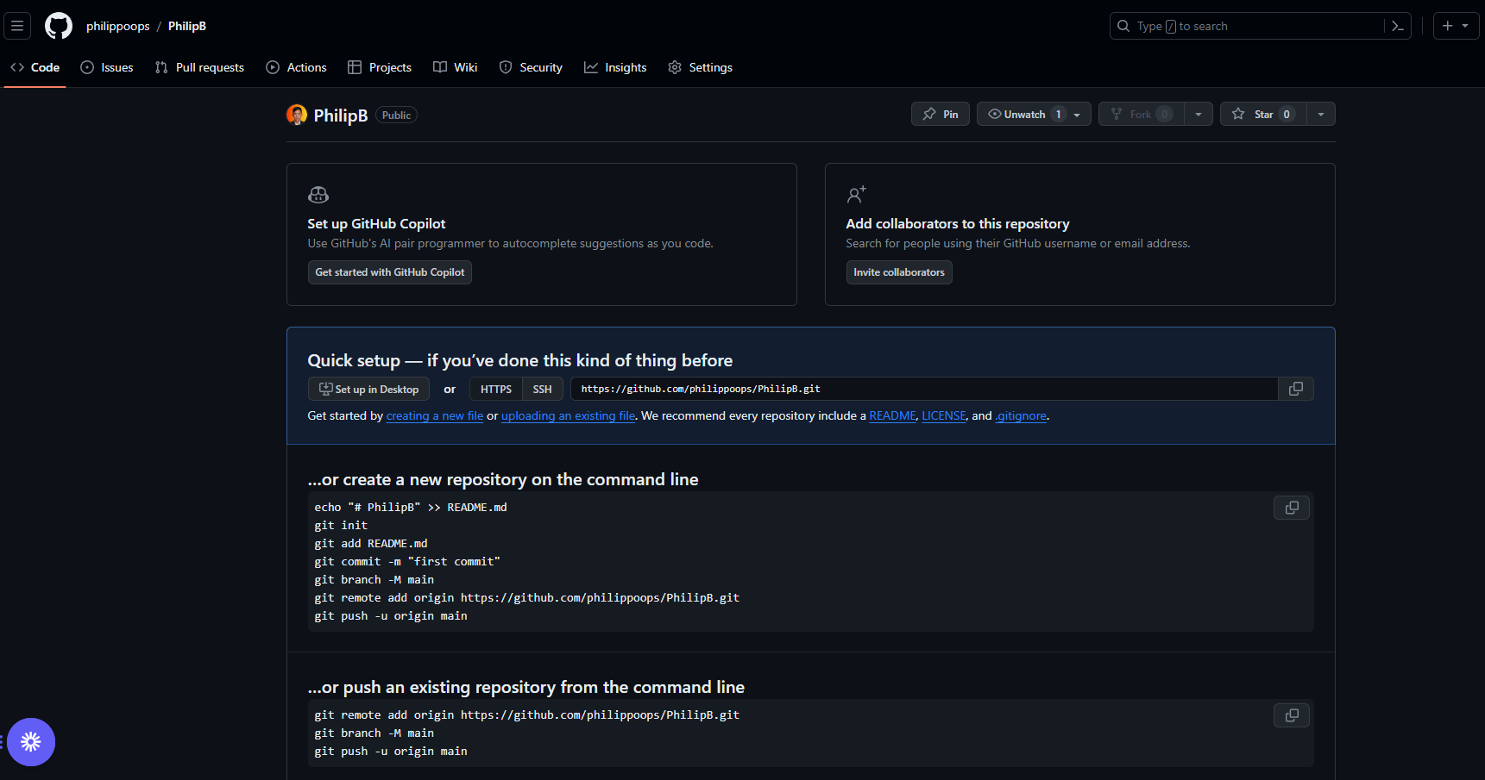
3. Create a file on my computer  
   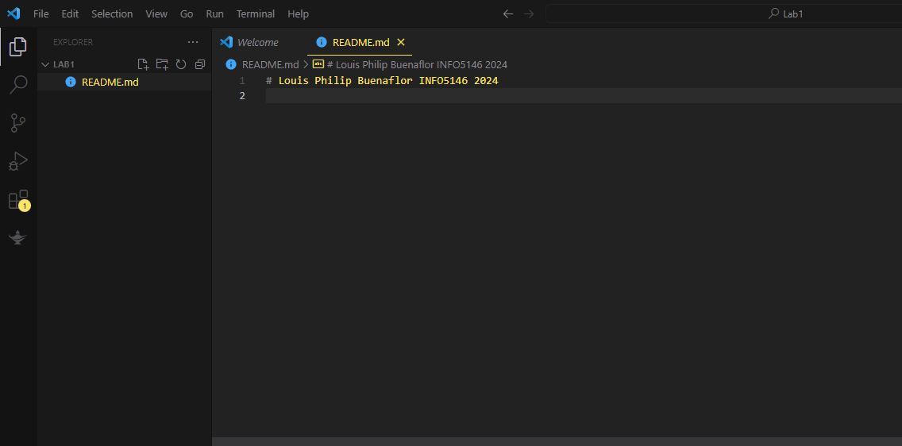
4. Initialize a git repository  
   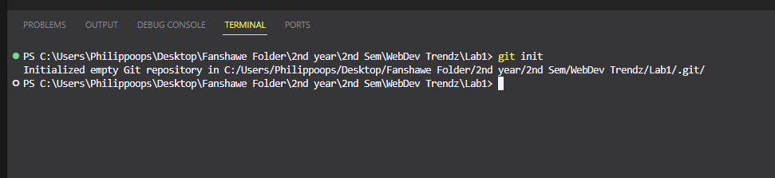
5. Add my remote origin and add file  
   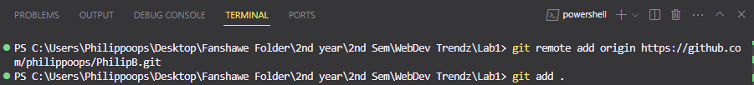
6. Commit my file  
     
     
   
7. Push my files to GitHub  
   